**Source 1:**

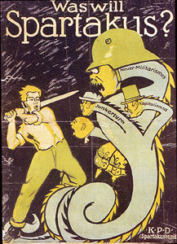

The source above is a poster by the Sparticists party in 1918 entitled in German “What does Sparticist want”. It shows how they intended to deal with rising militarism (Neuer Militarismus), capitalism (Kapitalismus) and the landowners (Junkertum).

**Source 2:**

The source below is a declaration by the German government’s minister for defence, early January 1919.

*“Workers! The government has entrusted me with the leadership of the republican soldiers. You know me and my history in the party… I promise that no unnecessary blood will be spilt. I am to cleanse, not destroy. With the new republican army I want to bring you freedom and peace. The working class must stand united against Spartacists if democracy and socialism are not to be lost”.*